

A PROJECT REPORT ON

BLACK FRIDAY DATASET



May 19, 2019

BY - AISHWARYA S

SUBJECT – INTERMEDIATE ANALYTICS

**INTRODUCTION**

In this analysis, we make use of our chosen dataset i.e. BlackFriday dataset. The main theme of our analysis is to perform basic data exploration to get an insight into the data and irregularities. Also, mainly to come up with the statistical inferences of the numerical as well as categorical variables. Along with this, the target variable would be graphically plotted with other variables in the dataset to describe the relationship between the same.

To predict the value of Purchase, a Linear Regression model would be built and root mean squared values are predicted.

**METHODS**

1. **Descriptive statistics** are the building blocks to understand the dataset in an efficient manner. It helps in the further analysis process and building an accurate model. In our case, the chosen dataset is the Black Friday dataset and we perform various operations posing various questions.
2. To obtain the inferences, we need to perform Analysis wherein, we need to understand the distribution of the numerical variables as well as categorical variables. So histograms would be a great fit to understand the data. This method is used to mainly understand the relationship between the target variable with the numerical as well as the categorical variable to draw the inferences (Medium, 2017).

Distribution of the target variable ‘Purchase’ is visualised in the form of histogram by using the ggplot(). It includes parameters such as

* ‘aes’ i.e. aesthetic mapping which describes how variables in the data are mapped
* geom_histogram represents the basic histogram with the value of bins

Then, one of the numerical predictor is considered - in our case ‘Occupation’ and we made use of various functions listed below to have numerical understanding of the predictor.

* summary()
* mean()
* sd()
* median()

Later, using the similar method as shown for the ‘purchase’ variable i.e. plotting a histogram of Purchase by Occupation with the help of ggplot() is performed.

And for the categorical predictor ‘Age’ ,the numerical data would be presented using the table() function and histograms are generated using the ggplot().

1. Regularization Methods to describe the relationship among the variables and make predictions using Linear Regression Model

This method would be used to build a model to predict the purchase amount of the buyer considering various products which would help the retailer to come up with the various discounts and offers against different categories of the products.

Here, the dataset is split into train and test data i.e. 70 and 30% of the data respectively. There exists missing values , data cleaning needs to be done and this is tackled by imputing Product_Category_2 and Product_Category_3 with 0’s and also transformation of various variables would be carried out.

The model is then built and then summarised. The model performance is then analysed with the help of ‘Root Mean Sqaured Error’.

1. Apriori Algorithm

It is a machine learning algorithm to find the best possible recommendation of product if the customer has purchased an item. The algorithm defined consists of set of rules which has to be defined to work. The result shows the confidence of other product if a consumer purchases one product. For example, in a store if a customer buys bread there is 70 percent chance that he would also buy jam. The percentage increases if jam is placed just beside the bread.

**ANALYSIS**

a) Various libraries required for Data Exploration and Data Profiling are installed into the workspace using install.packages() function and then the packages are loaded into the workspace in R Studio.

1. Finding the number of rows and columns in the dataset

To obtain the rows and columns we make use of the dim(data) function which stands for the Dimension function. It is useful in generating the dimension of the required array, matrix or data frame. In our case, the data is loaded into the data frame and dim() function is used.

The below snippet shows the output:



Therefore, BlackFriday dataset consists of 537577 rows and 12 columns in it.

1. Structure of the dataset

This is obtained by using the str(data) function which provides a complete information about the data frame. The below snippet includes a valuable set of information obtained from str() function.

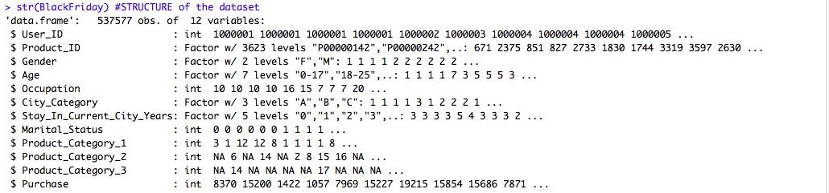

Here, the output consists of variables which are a combination of factors and integers. As mentioned earlier, it also mentions the number of rows and columns. However, it can also be observed that there are NA’s in some variables which represent the missing values and would be analyzed later in the report.

1. Properties of the dataset

The properties of the dataset include the skewness and range of the dataset. We make use of the describe(data) function in order to obtain the skewness of the data.

The below snippet shows the information obtained on using describe(data) function.

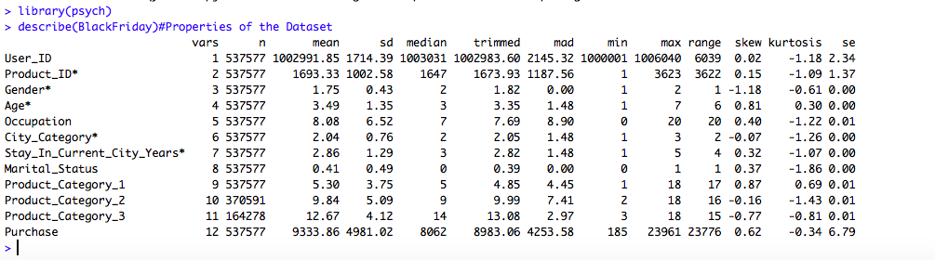

It shows the skewness of data and how each variable is distributed from normal distribution. Also, we can observe that Product_category_2 and Product_Category_3 are negatively skewed which shows more values are present under the median.

1. Missing Values

To check if there are any missing values, the following code is executed, and the missing data is plotted as shown in the below code snippet.



The plot obtained is as shown:



From the above plot, it can be seen that missing values do exist and it is in Product_Category_2 which is about 31% of the data and in Product_Category_3 which is around 69% of the data.

1. Number of items purchased by customer

To know the transactions made by the customer we find the mean of the purchases on the product categories along with the histogram which is as shown below:

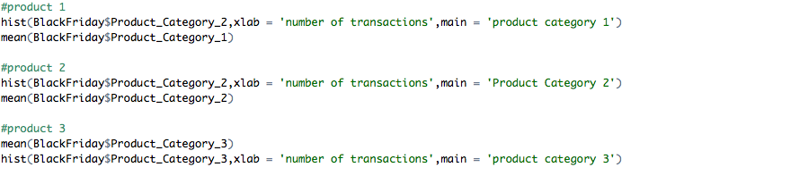



The above histogram shows that maximum number of people have only done one transaction in category 1. However, as we can see in the below code snippet, the mean of the transactions is 5.

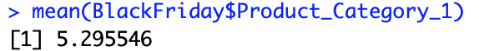



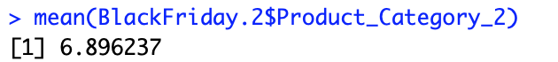

The above histogram shows that the maximum number of people have done 2 transactions in product category 2. However, the average number of transactions is between 2 to 7.



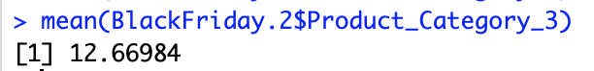

From the above histogram, it is clear that most of the customers have purchased and done more than 15 transactions in Product Category 3. Around, 100,000 customers have purchased more than 15 products on Black Friday.

1. Store Visitors ( Married/Unmarried)

We plot a histogram to have an insight about this feature.

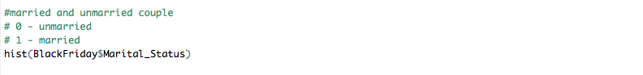



The above graph shows that more than 55%(270,000) transactions were done by single and around 45% transactions were done by married people.

1. Sales of category of products

This is performed as shown in the below code snippet.

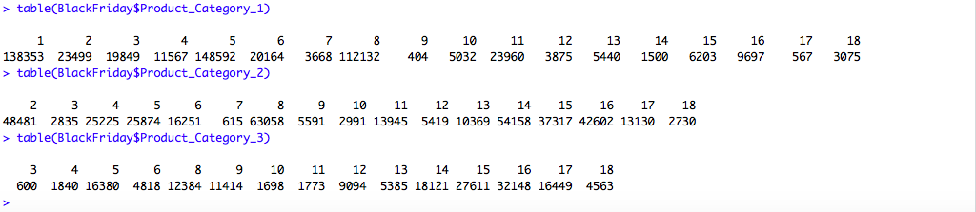

Therefore, it is clear that there are 5891 users and 3623 Product ID’s. Product Category 2 &3 had numerous missing values. By calculating the mean and constructing the histogram graphs shown above, out of all the 3 product categories we can clearly say that the product category 1 has highest number of sales on Black Friday.

1. Spendings of Age group

To find out the spending of various age groups we have made use of table() function as shown below.

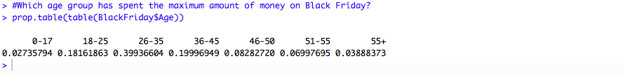

It is clearly observed from the above output that the age group ranging from 36-35 have spent more on purchasing on Black Friday.

b) Required libraries are loaded initially before starting with the analysis. The dataset is loaded into the workspace and then the structure of the loaded dataset is observed as shown below.

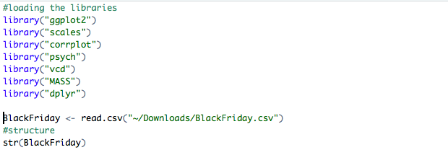

**Missing Values**

Missing values present in the dataset are obtained as shown in the below screenshot.

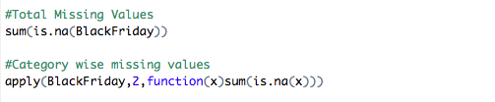

Missing values are observed in Product_Category_2 and Product_Category_3. Since it is a categorical type of data, it is sufficient to perform imputation. Hence, the missing values are imputed by 0’s.

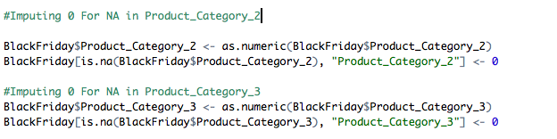

**Statistical inference**

Statistical inference is the department of records whereby we arrive at conclusions about a population. We can make inferences concerning numerous problems associated with the statistics, as an instance, the parameters of the opportunity distribution, the parameters of a given version that explains the connection amongst variables, goodness of fit to a chance distribution, and differences between organizations.

After Data Cleaning, Distribution of the Target variable ‘Purchase’ is obtained by using the ggplot() function and is as shown in the below code snippet (Johnston Lab, 2017).

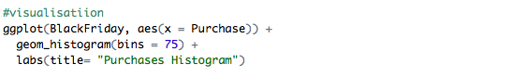

The plot obtained can be seen in the below snippet.



The above plot seems to appear almost as a Gaussian Distribution and has a positive skewness. The numerical stats of purchase is obtained with the help of summary() function.

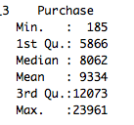

Here, it can be observed that purchase mean has higher value than that of purchase median. Hence it is positively skewed.

**Numerical Predictor: Occupation**

Numerical and Graphical outputs are obtained as shown below.

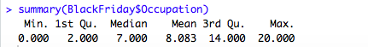

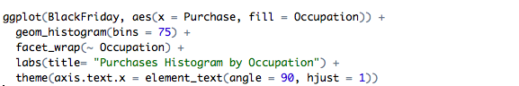



This is a plot which shows the relationship between the occupation of the customers and the purchase.

**Categorical Predictor: Age**

Categorical variables constitute kinds of statistics which may be divided into corporations. Examples of specific variables are race, sex, age institution, and educational level. While the latter variables will also be considered in a numerical manner via the use of specific values for age and maximum grade completed, it's far frequently extra informative to categorize such variables right into a rather small range of businesses.

The Numerical stats and Graphical output and the code is as shown below.

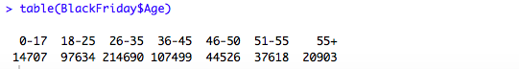

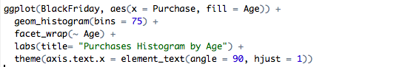



It can be clearly observed from the above plot of Purchase by Age that the age group ranging from 26-35 would shop more.

**Multicollinearity**

In order to build a model, we need to check whether multicollinearity exists by generating a correlation plot on the predictors so that we can know what variables to include in our model.

The below code is used to generate the correlation plot for the numerical predictors.



The below plot describes the multicollinearity of the numerical predictors.



From the above plot, it appears that no multicollinearity exists and it can be seen that no predictor has high impact on purchase. However, occupation seems to appear having highest correlation and the Product categories have negative correlation and are strong. So, in our case Product_Ctegory_2 and Product_Category_3 would be dropped in order to avoid multicollinearity.

**c) LINEAR REGRESSION MODEL**

This model would be built to predict the customer’s purchase amount. After performing Data Cleaning i.e. by imputing the value 0 to the product categories 2 and 3, we would also impute the user_ID and Product_ID to null since, it contains the variance 0. The code is as shown below.

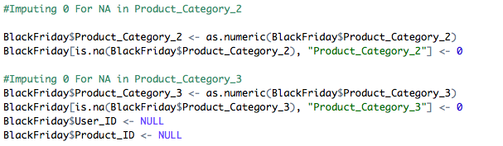

Now, we split the dataset into train and test dataset of 70 and 30% data samples. Here, it is to be noted that we split the data so that the training dataset is used for building the model and the test dataset is used for checking the accuracy of the model.

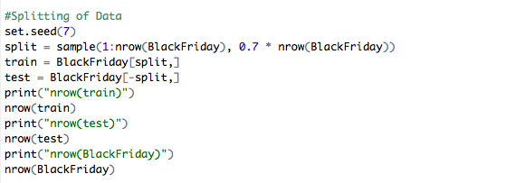

**Data Type Transformation**

The data types in the dataset are made up of factors and integers. Here, Marital status is integer and needs to be converted to a factor. Also, Gender must be converted to a factor.

Purchase and age must be an integer. Transformation is done for both the test and training dataset. It is done as shown in the below code snippet.

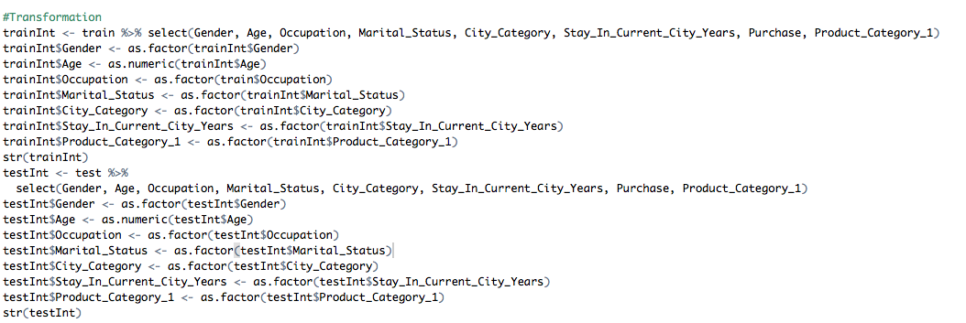

**Model Building**

The model is built as shown in the below code and we make use of ‘anova’ method as we have done imputation previously.

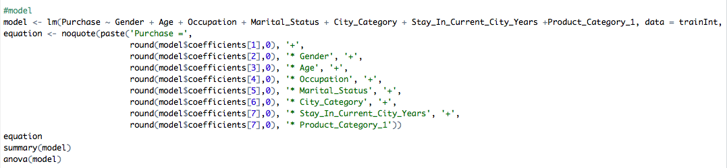

Equation obtained is as shown below



The summary of the model is obtained using the summary() function as shown below.

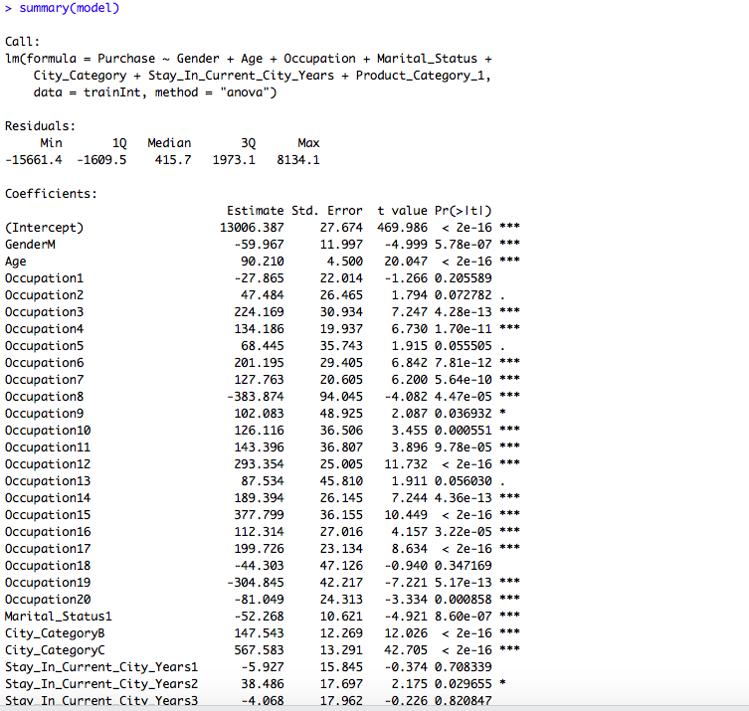

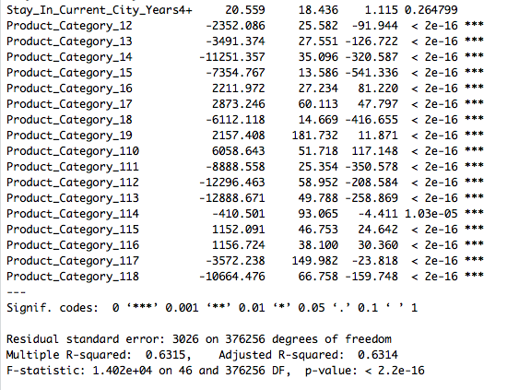

From the output, we can observe that the R-squared value is 0.6315 which appears to be a good one for prediction and the model has a good accuracy.

**Evaluation Metrics**

The Root Mean Squared Error abbreviated as RMSE is the square root of the average of squared errors. It acts as an evaluation metric. RMSE is always non-negative, and a value of 0 (almost never achieved in practice) would indicate a perfect fit to the data. In general, a lower RMSD is better than a higher one (En.wikipedia.org, 2019). The RMSE represents the sample standard deviation of the [differences between predicted values and observed values](https://gerardnico.com/data_mining/residual) (Gerardnico.com, 2016). The code for the prediction is as shown below.

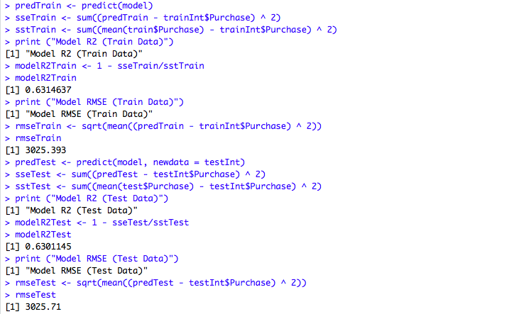

From the above output, it can be observed that the RMSE value of training data is 3025.393 where as for the test data it is 3025.71 . Hence, we can say that the model seems to be a pretty decent one.

**Accuracy Check**

We will perform a little accuracy check. The following code would generate the real and predicted purchase amount of the test dataset.

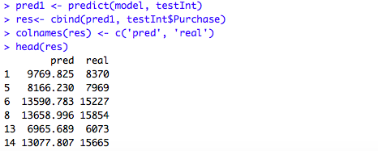

From the obtained predicted values, it can be observed that it is said to be a decent predictive model. By performing various other techniques we can check the accuracy of the model for this dataset.

**Residuals vs Fitted Values**

The plot for residuals vs fitted values plot obtained from the model is as shown below.

Firstly, the residuals vs fitted values are plotted and the QQ-plot is plotted it is obtained by the following piece of code.

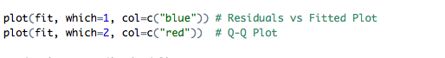

Plots are as shown below.

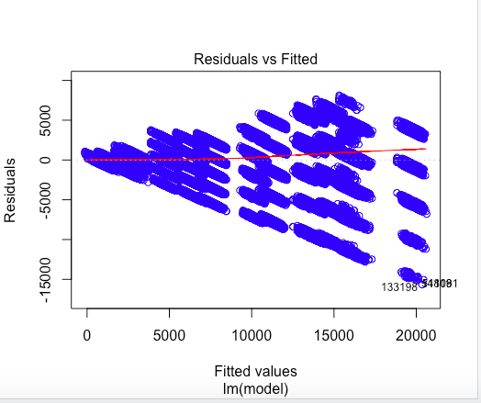

Here, it appears that some points go out of the units. But however, it seems to be a decent model from the patterns observed.

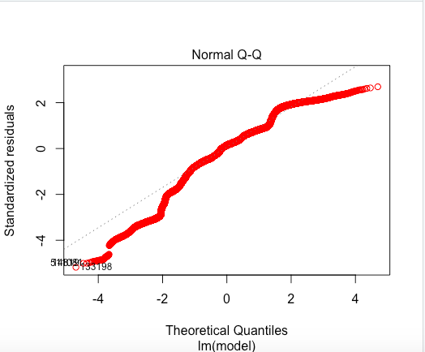

Q-Q plot generally would show the normally distributed residuals and in our model, it comes out to be a decent alignment with few points below the line.

From this model what we understood was the purchase amount mostly depend on the categories of the product and the marital status of the customer. The main insight was that singles would buy the products more than married customers i.e. for males and female customers change their buying priority based on their marital status.

**Customer Products**



Top 25 products of the store

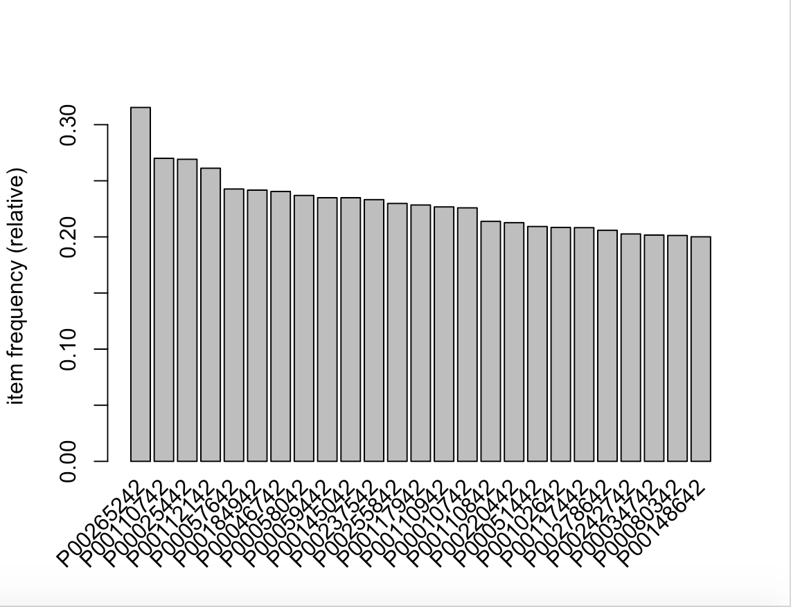

**d) APRIORI ALOGORITHM**

The below are the required packages for apriori algorithm.

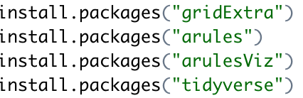

The machine learning algorithm aprori works on binary values of the data. For the algorithm to work correctly, the Customer product data is converted into sparse matrix. Apriori is an inbuilt function of the package arules. The binary value is 1 if the data product is purchased by the customer and 0 if the data is not purchased by the customer.

The apriori algorithm can be implemented on the mine frequent itemset or maximum frequent products of the Black Friday sale. In this project we are using top 5 selling products and performing the apriori algorithm.

Firstly, we try to find the Item Frequency of top most selling products of the sale.

Secondly, we set the rule for the first parameter based on the confidence. For example, the algorithm only works if transactions for product are above 50. As we can’t predict the recommendation based on a single transaction

The default confidence level of the apriori algorithm is 80%. We will change the confidence level and check the output based on the domain knowledge of the product.

**Apriori code**

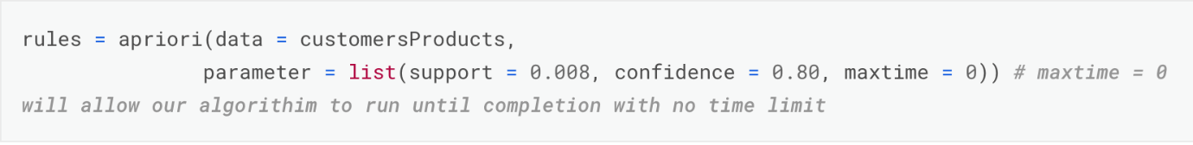

The output will be the product id with support, confidence, lift and count which are the parameters the apriori takes into consideration to give out recommendations.

**Output**

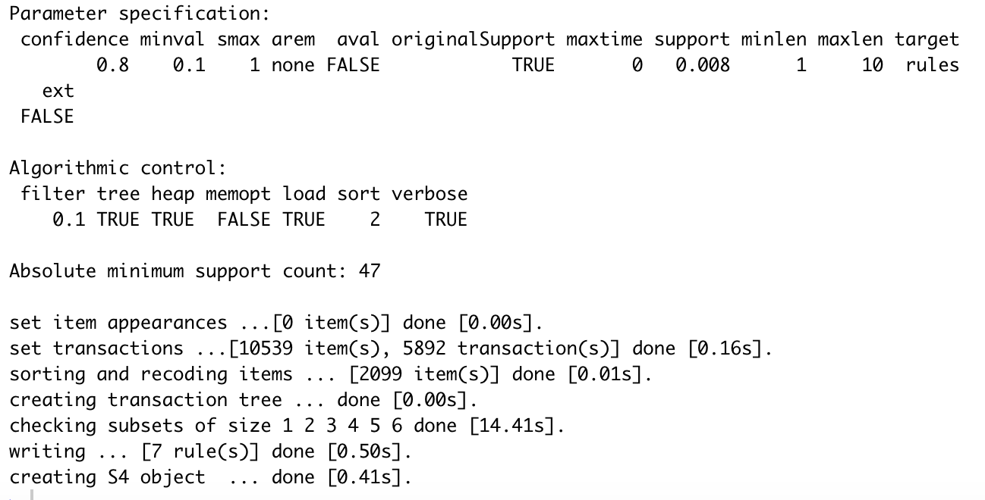

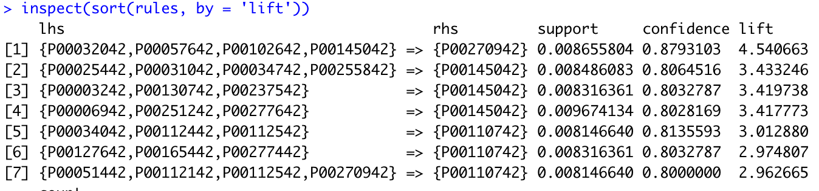

It displays a product id -> p00270942 will also purchase p00032042, p00057642 with confidence of 80%. The output displays the confidence level and support of an item which is most likely to be purchased when a customer purchases an item.

The minimum confidence level is set to be 80% for the product to be a recommendation.



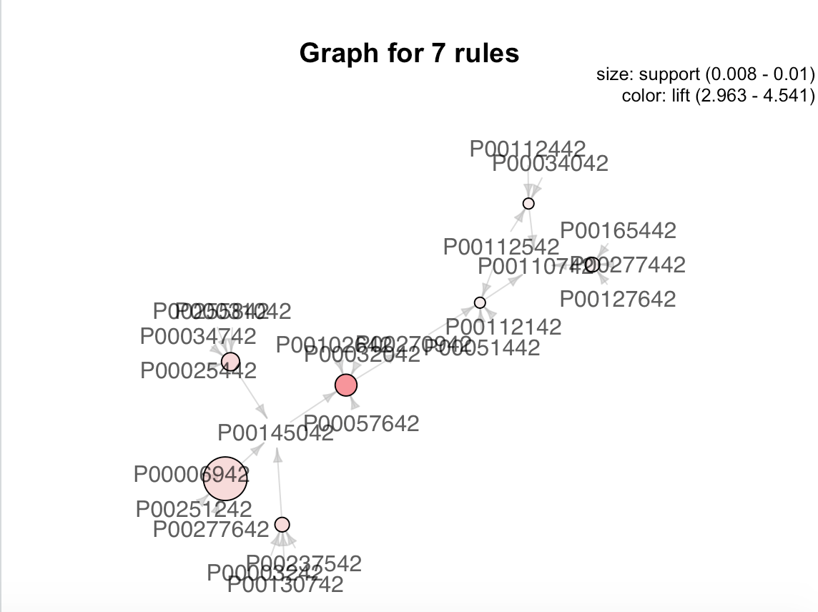

The above graph shows the association rules. The graph has seven rules based on which recommendation are calculated for a transaction. The bigger the bubble, higher the support for the product, it tells us that it’s a good recommendation that can be pushed to customer.

**CONCLUSION**

To conclude with our analysis on Black Friday dataset, we have performed numerical and graphical predictor analysis, data cleaning, linear regression model, evaluation metrics and accuracy checks on the dataset. Based on the three checks that we performed, i.e., the accuracy check, RMSE and the R squared value, it appears to be a decent regression model. However, it needs to be compared with our predictive models to actually comment on the model. We have learnt and implemented a new machine learning algorithm called ‘Apriori Algorithm’ to determine the confidence of level of the products in the dataset.

**REFERENCES**

En.wikipedia.org. (2019). Root-mean-square deviation. [online] Available at: <https://en.wikipedia.org/wiki/Root-mean-square_deviation>.

Gerardnico.com. (2016). Data Mining - Root mean squared (Error|Deviation) (RMSE|RMSD) [Gerardnico]. [online] Available at: <https://gerardnico.com/data_mining/rmse>.

Johnston Lab. (2017). A quick and easy function to plot lm() results with ggplot2 in R. [online] Available at: <https://sejohnston.com/2012/08/09/a-quick-and-easy-function-to-plot-lm-results-in-r/>.

Medium. (2017). Black Friday: How much will a customer spend?. [online] Available at: <https://medium.com/diogo-menezes-borges/project-3-analytics-vidhya-hackaton-black-friday-f6c6bf3da86f>.

**APPENDIX**

